Cora Pearl (Harshman) Holloway
September 26, 1895 – June 17, 1916

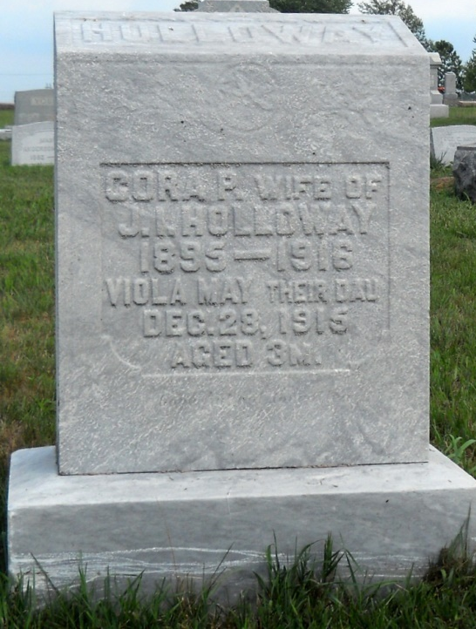
Photo by Jackie Sanders

Cora Pearl Holloway
in the Indiana, Death Certificates, 1899-2011
Name: Cora Pearl Holloway
[Cora Pearl Harshman]
Gender: Female
Race: White
Age: 20 years, 8 months, 21 days
Marital status: Married
Birth Date: 26 Sep 1916 [sic]
Birth Place: Indiana
Death Date: 17 Jun 1916
Death Place: Nottingham, Wells, Indiana, USA
Father: Royal Harshman
Mother: Eliza J. Prody
Spouse: James Irey Holloway
Informant: Royal Harshman; Petroleum, Ind.
Burial: June 19, 1916; Alberson Cemetery, Petroleum, Ind.

