Mary Hilton-Lee
1830 - 1854

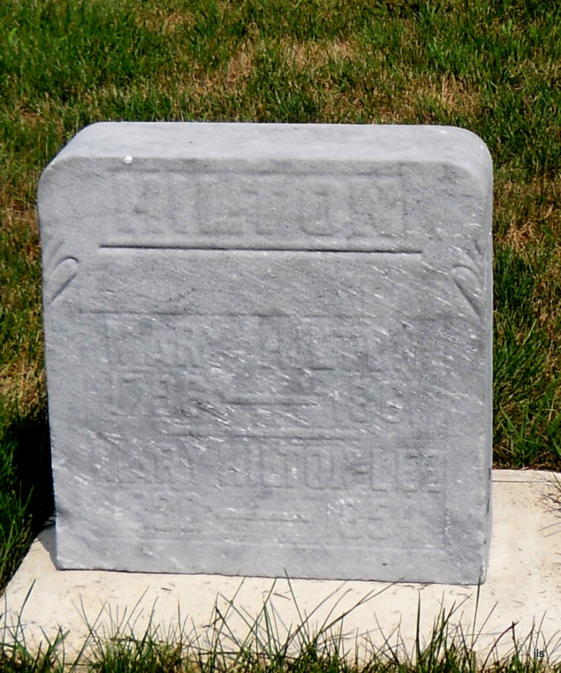
Photo by Jackie Sanders

No obit found at this time

