Rebecca Jane (Beaman) Higgins
April 12, 1840 – June 24, 1900

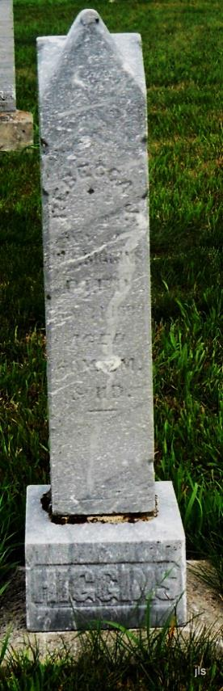
Photo by Jackie Sanders

Adams Public Library System (Decatur, IN) online obit abstracts
Publication: Decatur Daily Democrat; Date: 28 JUN 1900
Title: Higgins, Rebecca
Subject: Obituaries -- H -- 1900-1909
Abstract: Age 60 years 3 months 11 days
Died: Sunday, June 24, 1900
*****
Rebecca Jane Higgins
in the Indiana, Death Certificates, 1899-2011
Name: Rebecca Jane Higgins [Rebecca Jane Beaman]
Gender: Female; Race: White; Age: 60 years, 2 months, 11 days
Marital status: Widowed
Birth Date: abt 1840; Birth Place: Stotts Co Ohio
Death Date: 24 Jun 1900; Death Place: Hartford, Adams, Indiana, USA
Father: Thomas Beaman
Burial: June ??; Alberson Cemetery

