William D. Hesher
October 12, 1877 – March 1, 1956

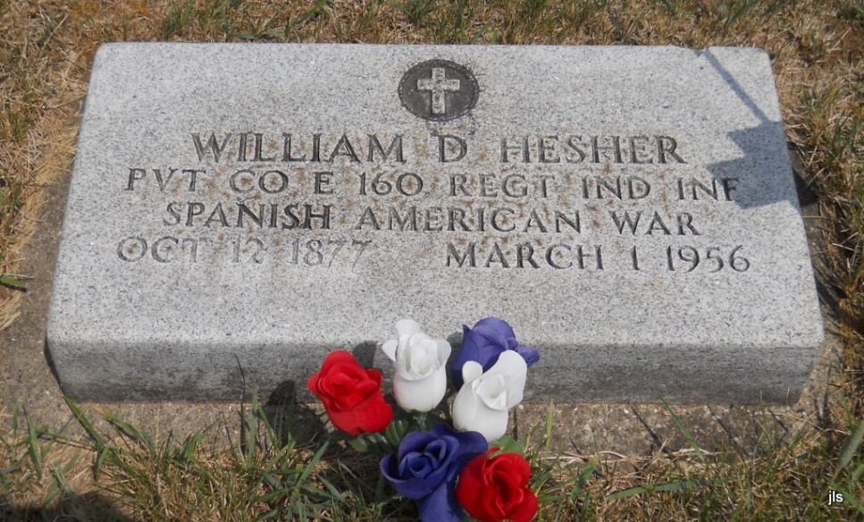
Photo by Jackie Sanders
William D Hesher
in the Indiana, Death Certificates, 1899-2011
Name: William D Hesher
Gender: Male
Race: White
Marital status: Married
Death Date: 1 Mar 1956
Death Place: Blackford, Indiana, USA
Father: Fredrick Hesher

