Franklin Daniel Herman
March 1, 1890 – December 14, 1955

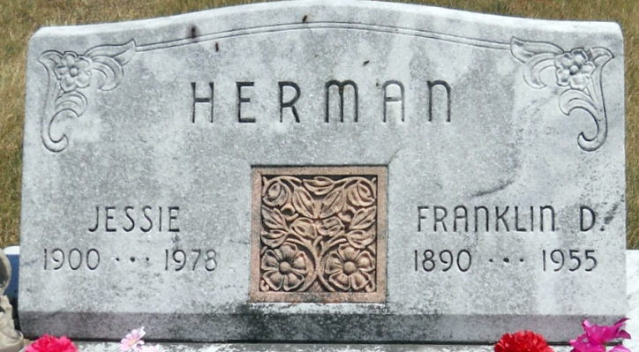
Photo by Jackie Sanders
Handwritten date: Wednesday, December 14, 1955

FRANK HERMAN OF HARTFORD TP. SUCCUMBS TODAY
Stroke Fatal to Well Known Framer; Rites Here Friday

Franklin D. Herman, 65, well known Hartford Township farmer residing on Geneva R.R. 1, died at 7:25 a.m. today at the Adams County Memorial Hospital. Mr. Herman was admitted to the hospital yesterday after suffering a stroke at his home. He had not been well for one year.
Born in Hartford Township, March 1, 1890, Mr. Herman was a lifelong resident of that township. He was the son of Amos and Elizabeth Pontius Herman. He was married to Jessie Kaves on Nov. 1, 1917. She survives
Also surviving are the following children: Donald F. Herman, Linn Grove; Mrs. Virgil (Garnett) Bixler, Decatur; Mrs. Alton (Velma) Wable, Monroe R. R. 1; Franklin Dale Herman, New Corydon; Mrs. Burvil (Ruth) Watkins, Pleasant Mills; Daniel F. Herman, Berne; Robert L. Herman Geneva R. R. 2, and Alvin W. Herman, at home. Eight grandchildren and two brothers survive. The brothers are Charles Herman, Geneva R. R. 1 and Bert Herman, Columbia City. Two sisters preceded in death.
The body is at the Yager Funeral Home where friends may call after 12 noon on Thursday. Services will be held at the funeral home at 2 p.m. Friday, Rev. Herald J. Welty, pastor of the Decatur Missionary Church officiating. Burial will be in Alberson Cemetery near Linn Grove.

Adams County Historical Museum, Adams County, Indiana
March 1955 – April 1958 Scrapbook
*****
Indiana, Death Certificates, 1899-2011

Name: Franklin D Herman
Gender: Male
Race: White
Age: 66
Marital Status: Married
Birth Date: 1 Mar 1880
Birth Place: Hartford Twp, Adams Co
Death Date: 14 Dec 1955
Death Place: Decatur, Adams, Indiana, USA
Father: Amos Herman
Mother: Elizabeth Pontius
Burial: Dec. 16, 1955 Alberson Cemetery, 10 s/w of Berne

