Leon C. Heller
April 12, 1914 – April 18, 1914
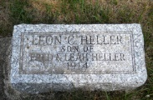

Photo by Jackie Sanders

Leon C. Heller
in the Indiana, Death Certificates, 1899-2011
Name: Leon C. Heller
Gender: Male
Race: White
Age: 6 days
Marital status: Single
Birth Date: 12 Apr 1914
Birth Place: Muncie, Ind.
Death Date: 18 Apr 1914; premature birth
Death Place: Muncie, Delaware, Indiana, USA
Father: Fred Heller
Mother: Leah Warner
Burial: April 19, 1914; Keystone, Wells County

