Flossie Irene (Ochsenrider) Heller
February 5, 1900 – December 5, 1987
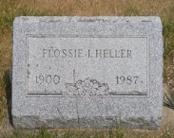

Photo by Jackie Sanders
Flossie Heller
in the Indiana, Death Certificates, 1899-2011
Name: Flossie Heller
[Flossie Ochsenrider]
Gender: Female
Race: White
Age: 87
Marital status: Widowed
Birth Date: 5 Feb 1900
Birth Place: Ind
Death Date: 5 Dec 1987
Death Place: Marion, Grant, Indiana, USA
Father: David Ochsenrider
Mother: Sarah Foust
Informant: Maxine Sanders; daughter; Upland, Ind.
Burial: Dec. 8, 1987; Alberson Cemetery, Domestic, Wells Co., Ind.

