Daniel Heller
August 19, 1826 – November 17, 1900
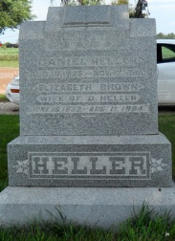

Photo by Jackie Sanders
Daniel Heller
in the Indiana, Death Certificates, 1899-2011
Name: Daniel Heller
Gender: Male; Race: White; Age: 74 years, 2 months, 18 days
Marital status: Widower
Birth Date: abt 1826; Birth Place: Penna
Death Date: 17 Nov 1900; Death Place: Hartford, Adams, Indiana
Father: Levi Heller
Informant: John W. Heller; Geneva, Ind.
Burial: Nov. 19; Alberson Cemetery
*****
Daniel Heller was born in Cumberland County, Maryland, August 26, 1826, and immigrated to Indiana about 1840, where he resided until his death, which occurred Nov. 17, 1900, aged 74 years, 2 months and 21 days.

Decatur Democrat, Adams County, IN; Thursday, Nov. 22, 1900

Contributed by Karin King

