Daisy Belle (Turner) Heller
July 13, 1878 – October 7, 1957
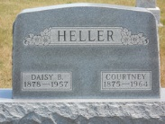

Photo by Jackie Sanders
Daisy Belle Heller
in the Indiana, Death Certificates, 1899-2011
Name: Daisy Belle Heller
[Daisy Belle Turner]
Gender: Female
Race: White
Age: 79
Marital status: Married
Birth Date: 13 Jul 1878
Birth Place: Franklin Co., Ohio
Death Date: 7 Oct 1957
Death Place: Marion, Grant, Indiana, USA
Father: Henry Turner
Mother: Mary C. Borror
Informant: Courtney Heller; husband;
Burial: Oct. 10, 1957; Alberson Cemetery, Adams County, Ind.

