Joseph “Joe” Havens
August 27, 1892 – November 30, 1912
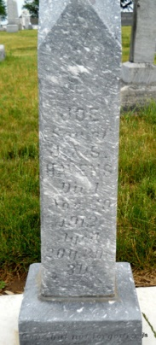

Photo by Jackie Sanders
Joseph Havens
in the Indiana, Death Certificates, 1899-2011
Name: Joseph Havens
Gender: Male; Race: White; Age: 20; Marital status: Single
Birth Date: Aug 1892; Birth Place: Indiana
Death Date: 30 Nov 1912; Ran over by railroad
Death Place: Van Buren, Grant, Indiana, USA
Father: John Havens; Mother: Sarah Murray
Informant: Alex Murray; Warren, Ind.
Burial: Dec. 3, 1912; Domestic, Ind.

