John Havens
March 10, 1812 – March 4, 1889
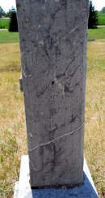

Photo by Jackie Sanders

No obit found at this time

