Elizabeth Havens
August 20, 1819 – March 20, 1885
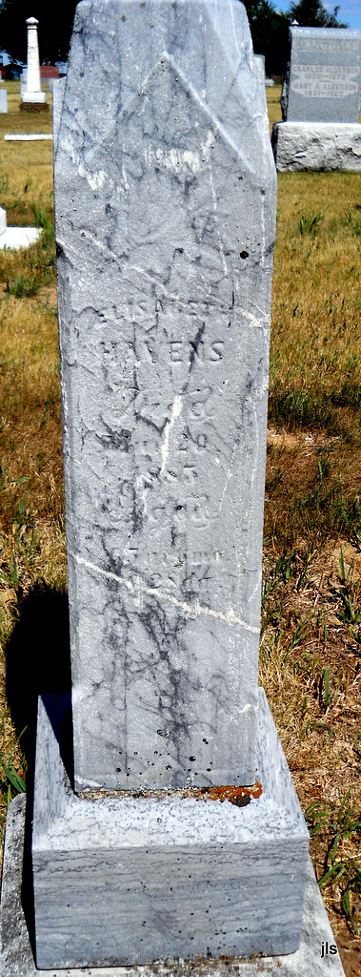

Photo by Jackie Sanders

No obit found at this time

