Gaynell Harshman
July 12, 1900 – January 25, 1993
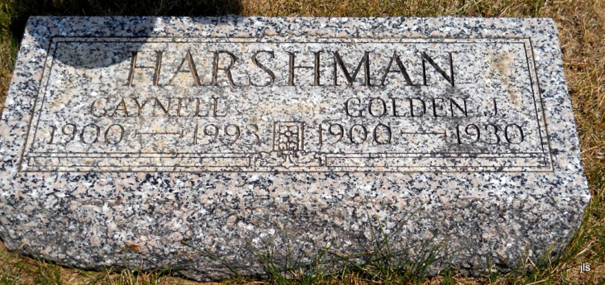
Photo by Jackie Sanders

MONTPELIER –

Gaynell Harshman, 92, died at 8:32 p.m. Monday at Wells Community Hospital, Bluffton. She was a homemaker. Her husband, Golden Jeff, died in 1930.
Surviving are a daughter, Wilmina Avey of Ossian; four sisters, Bessie Templin of Albany, Vava Albertson of Markle, Lenora Mills of Bryant, and Isca McCollum of Geneva; one grandchild; and two step great-grandchildren. Services at 1:30 p.m. Thursday at Goodwin Memorial Chapel, Bluffton. Calling from 1-9 p.m. today. Burial in Alberson Cemetery.

Fort Wayne Journal-Gazette (IN); January 27, 1993, Page 20

