Florence Harshman
1899 - 1970
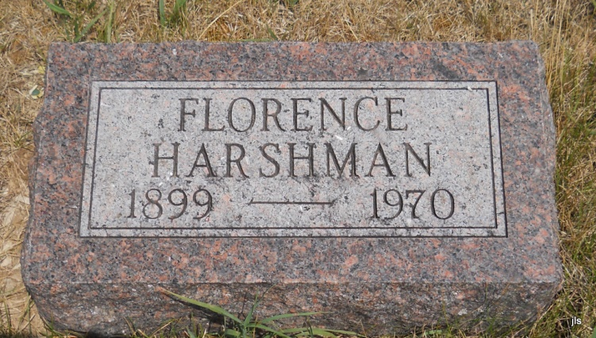
Photo by Jackie Sanders

No obit found at this time

