Edward Sylvester Hall
June 26, 1867 – April 2, 1931
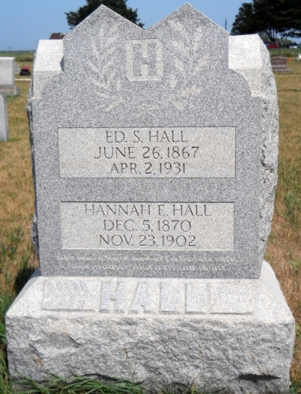
Photo by Jackie Sanders

Ed. S. Hall
in the Indiana, Death Certificates, 1899-2011
Name: Ed. S. Hall
Gender: Male; Race: White; Age: 63; Marital status: Married
Birth Date: 26 Jun 1867; Birth Place: Indiana
Death Date: 2 Apr 1931; Death Place: Huntington, Indiana, USA
Father: John V Hall; Mother: Mary A Burgess
Spouse: Emma Hall
Informant: Emma Hall; Warren, Indiana
Burial: April 5, 1931; Alberson Cemetery, Wells Co.

