Julian P. Guyot
1875 – April 29, 1925
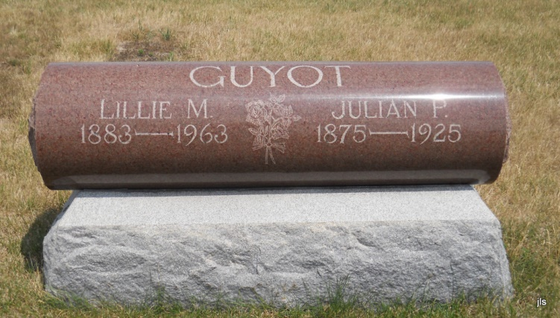
Photo by Jackie Sanders

Adams Public Library System (Decatur, IN) online obit abstracts
Publication: Decatur Daily Democrat;
Date: 02 MAY 1925
Title: Guyot, Julian
Subject: Obituaries -- G -- 1920-1929
Abstract: Died: Wednesday, April 29, 1925
Lived in Geneva

