Edna Sarah (Zimmerman) Guyot

March 19, 1914 – January 31, 2007

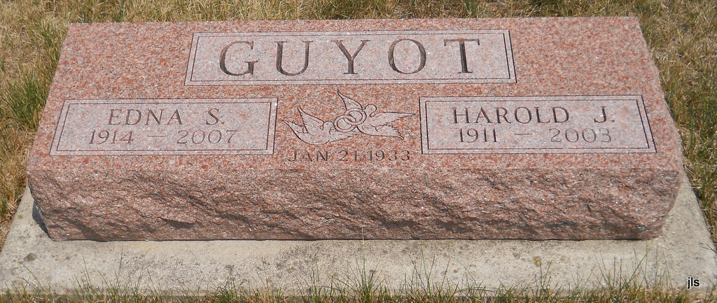

Photo by Jackie Sanders

News-Sentinel, The (Fort Wayne, IN) - Thursday, February 1, 2007
EDNA SARAH GUYOT, 92, formerly of Fort Wayne, died Wednesday, Jan. 31, 2007, at Miller's Merry Manor, Syracuse. Born March 19, 1914, in Saskatchewan, Canada, she was a member of Waynedale United Methodist Church and the Elex Club at G.E. She worked at General Electric for 18 1/2 years, retiring in 1969. Surviving are her sons, Keith B. (Dixie) Guyot of Charles Town, W. Va. and H. Philip (Carole) Guyot of Tucson, Ariz.; daughter, Linda C. (Richard) Waterson of Syracuse; sisters, Emma Grile of Fishers and Martha Sommer of Berne; nine grandchildren; 15 great-grandchildren; and four great-great-grandchildren. She was preceded in death by her husband, Harold J. Guyot, in 2003; brothers, Irvin and Orley Zimmerman; and sister, Ruby Richey. Funeral Service is 2 p.m. Saturday at Elzey-Patterson & Rodak Home For Funerals, 6810 Old Trail Road, Fort Wayne. Visitation is from 4 to 7 p.m. Friday at the funeral home. Private committal service in Albertson Cemetery. Memorials to Cancer Services of Northeast Indiana or United Methodist Church.
*****

Journal Gazette, The (Fort Wayne, IN) - Saturday, February 3, 2007

GUYOT, EDNA SARAH
Funeral Service is 2 p.m. today at Elzey-Patterson & Rodak Home For Funerals, 6810 Old Trail Road, Fort Wayne.

