Mabel M. (Crain) Franks
1895 - 1979
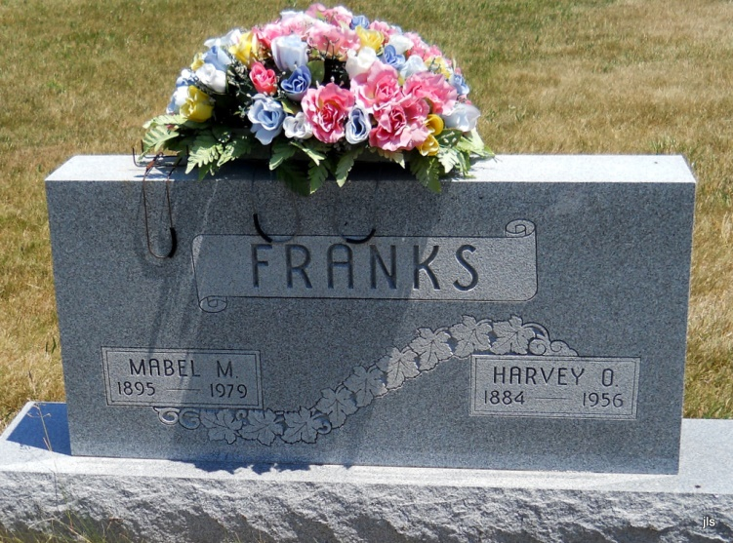
Photo by Jackie Sanders

No obit found at this time

