Harvey O. Franks
1884 – April 28, 1956
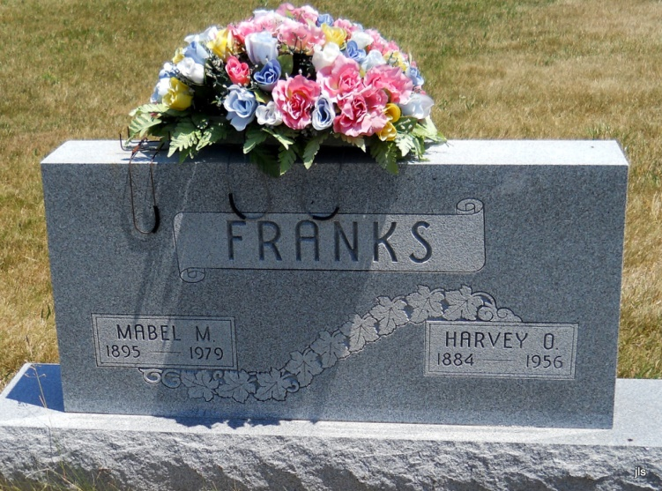
Photo by Jackie Sanders
Harvey O. Franks, of Bluffton, Ind. died Sunday in the Wells County Hospital at Bluffton after about six months of failing health. He was the father of Darrell W. Franks, of George Street, superintendent of the Hoaglin-Jackson School.
Mr. Franks was a resident of Wells County most of his lifetime and he was a member of the New Salem Methodist Church.
Surviving besides his son, are his widow, the former Mabel Crain; two daughters, Mrs. Paul Stevens of LaFontaine, Ind., and Mrs. Ruth Riddle of Sturgis, Mich.; a sister, Mrs. Za Shiere of Toledo, and two grandchildren.
Rites will be held at 1:30 p.m. Wednesday at the Thoma Funeral Home in Bluffton and burial will be in the Alberson Cemetery.

Van Wert Times Bulletin, Van Wert County, OH
Tuesday, May 1, 1956

