Katherine D. (Grogg) Fields
December 24, 1933 – October 15, 2002
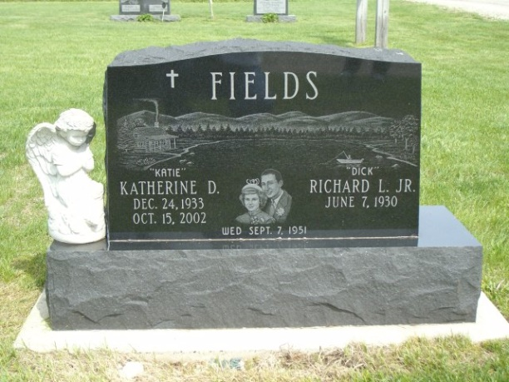
Photo by Jackie Sanders

Katherine D. "Katie" Fields, 68, of Geneva, a member of Cross United Church of Christ, died Tuesday, Oct. 15, 2002, at St. Joseph Hospital in Fort Wayne. The Adams County native was an aide for South Adams Schools for 30 years and a Sunday school teacher.
Surviving are her husband, Richard L. Jr.; a son, John C. of Converse; daughters, Deborah L. Fields of Newberg, Ore., Linda L. Fields of Tualtin, Ore., and Barbara A. Hirschy of Decatur; brothers, Robert Grogg of Portland and Tom Grogg of Geneva; sisters, Betty Schmidt of Mendon, Ohio, Patricia Moser of Linn Grove and Maryann Bailey of Geneva; 11 grandchildren; one great-grandchild; and two step greatgrandchildren.
Services are 10:30 a.m. Saturday at Cross United Church of Christ, Geneva, with calling one hour before services. Calling is also from 2 to 8 p.m. Friday at Yager-Kirchhofer Funeral Home, Berne. Burial will be at Alberson Cemetery, Linn Grove. Memorials are to the church Building Fund or Swiss Heritage Society.

News-Sentinel, Allen County, Indiana
October 16, 2002

*****
Katherine D. “Katie” Fields, 68, of Geneva, an aide in the South Adams School District for 30 years, died at 11:05 am Tuesday, October15 at St. Joseph Hospital in Fort Wayne.
Mrs. Fields served as an aide in the mathematics and science department for three decades at South Adams. She was a Limberlost Girl Scout leader for many years and a Sunday school teacher at Cross United Church of Christ, of which she was a member and formerly was an active member of the Domestic Church of Christ.
She was born in Adams County, De ember 24, 1933, a daughter of Glen C. and Hazel Morgan Grogg. Her marriage in Adams County on September 7, 1951 was to Richard L. “Dick” Fields, Jr., who survives.
Additional survivors are a son, John C. of Converse; three daughters, Deborah L. Fields of Newberg, Oregon; Linda L. Fields of Tualtin, Oregon and Barbara A. Hirschy of Decatur; two brothers, Robert Grogg of Portland and Tom Grogg of Geneva; three sisters, Mrs. Ben (Betty) Schmidt of Mendon, Ohio; Patricia “Pat” Moser of Linn Grove and Mrs. Jim (Maryann) Bailey of Geneva; 11 grandchildren; one great-grandchild; and two step great-grandchildren. Two brothers and one sister are deceased.
Services will be at 10:30 am Saturday at the Cross United Church of Christ with Rev. Randall Luther and Rev. Jerry Flueckiger officiating. Burial will be in Alberson Cemetery at Linn Grove.
Calling hours at Yager-Kirchhofer Funeral Home at Berne will be Friday from 2 to 8 pm and at the church Saturday for one hour prior to services.
Memorials to the church’s building fund or to the Swiss Village Society.

Bluffton News-Banner, Wells County, Indiana
October 16, 2002

