Mary Gladys Eckrote
August 30, 1901 – January 6, 1903
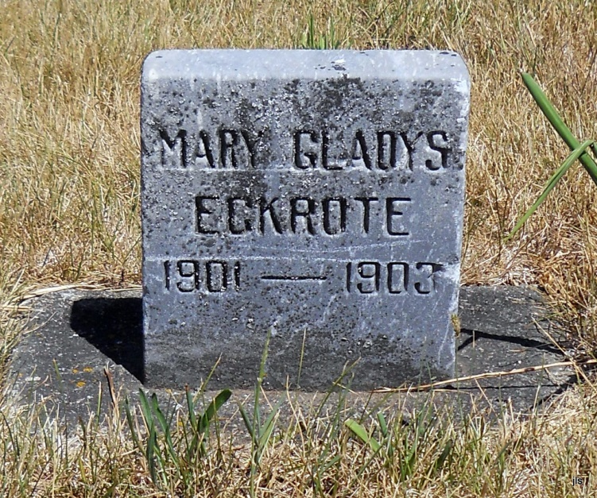
Photo by Jackie Sanders

Mary Gladis Eckrote
in the Indiana, Death Certificates, 1899-2011
Name: Mary Gladdis Eckrote
Gender: Female
Age: 1
Birth Date: 30 Aug 1901
Birth Place: Adams
Death Date: 6 Jan 1903; Rickets
Death Place: Hartford, Adams, Indiana, USA
Father: J E Eckrote
Mother: Lauretta
Informant: J. E. and L. Eckrote; Linn Grove
Burial: Jan. 8, 1903; Alberson Cemetery

