Anna Dunwiddie
September 7, 1853 – February 18, 1875

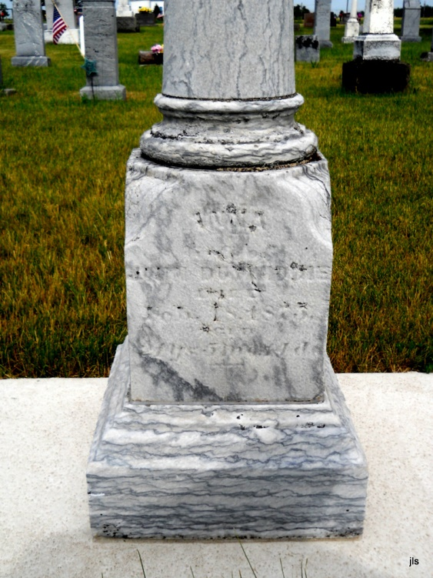
Photo by Jackie Sanders

No obit found at this time

