Charlotte Dial
1876 - 1916

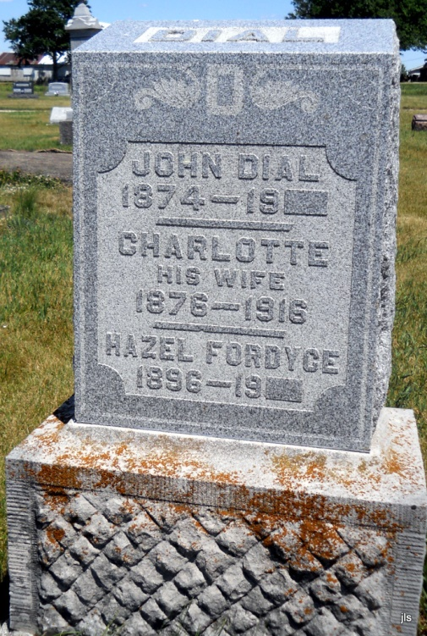
Photo by Jackie Sanders

No obit found at this time

