Malinda O. Davison
September 2, 1873 – December 10, 1900
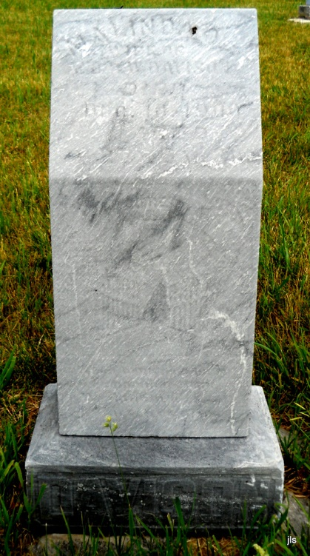

No obit found at this time

