Rex J. Darrah
August 3, 1926 – November 3, 2008

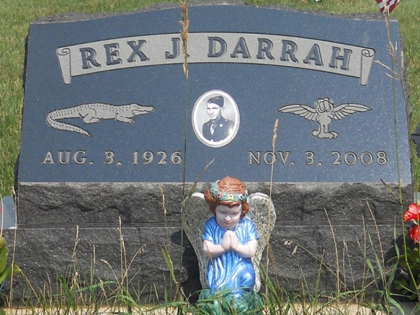
Photo by Jackie Sanders

Rex J. Darrah, 82, Berne, died Monday at Persimmon Ridge in Portland.
Born in Albion, Iowa, to Samuel J. and Hazel (Brown) Darrah, he was married on June 6, 1953, to Grace (Thompson) Darrah, who survives in Geneva.
A veteran of the United States Army serving during World War II, he was a retired truck driver.
Surviving besides his wife two daughters, Mrs. Kenneth (Suzette) Wills, Marble Falls, Texas, and Sharon L. Crago, Geneva; a son, Richard Jay Darrah, Lake Mary, Fla.; a sister, Irene Laws, Iowa; and two grandchildren.
Private family services will be held. Yager-Kirchhofer Funeral Home in Berne is in charge of the arrangements.

Commercial Review, Jay County, IN; November 7, 2008

