Martha (Jones) Croy-Emery
July 2, 1877 – November 28, 1942

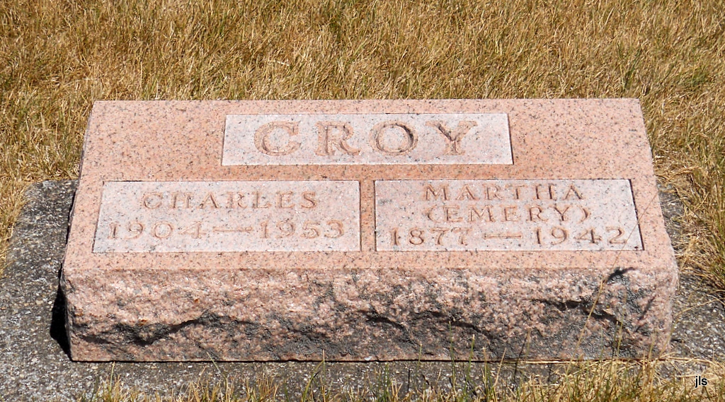
Photo by Jackie Sanders

Martha Emery
in the Indiana, Death Certificates, 1899-2011
Name: Martha Emery
[Martha Jones]
Gender: Female
Race: White
Age: 65
Marital status: Widow
Birth Date: 2 Jul 1877
Birth Place: Indiana
Death Date: 28 Nov 1942
Death Place: Hartford, Blackford, Indiana, USA
Father: Enos Jones
Mother: Belle ??
Informant: Francis Croy; Vera Cruz, Indiana
Burial: Dec. 1, 1942; Alberson Cemetery, Adam Co.

