Pearl (Clendenin) Cross
May 17, 1882 – January 21, 1967

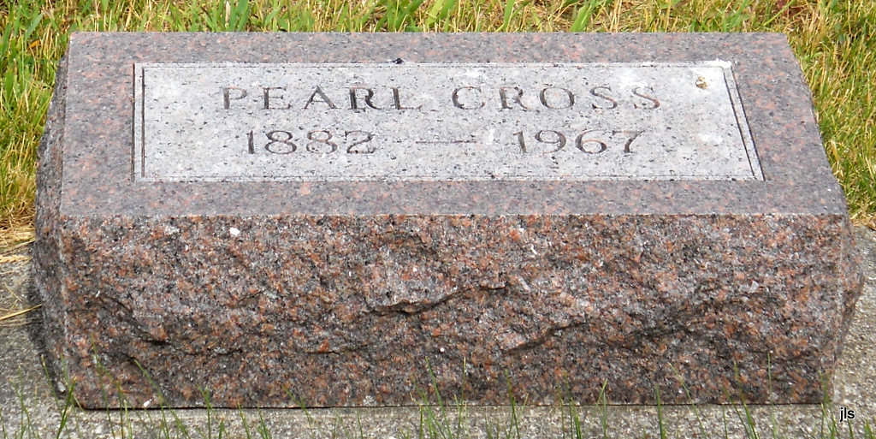
Photo by Jackie Sanders

Adams Public Library System (Decatur, IN) online obit abstracts
Publication: Decatur Daily Democrat; Date: 23 JAN 1967, p. 1
Title: Cross, Pearl
Subject: Obituaries -- C -- 1960-1969
Abstract: Age 85
Died: Saturday, January 21, 1967 in the Richmond State Hospital in Richmond, IN
Resident of Geneva, IN
*****
Pearl Cross
in the Indiana, Death Certificates, 1899-2011
Name: Pearl Cross
[Pearl Clendenin]
Gender: Female
Race: White
Age: 75
Marital status: Divorced
Birth Date: 17 May 1881
Birth Place: Indiana
Death Date: 20 Jan 1967
Death Place: Rural, Wayne, Indiana, USA
Father: William Clendenin
Mother: Amanda Allen Snyder
Informant: Richmond State Hospital Medical Records
Burial: Jan. 23, 1967; Alberson Cemetery

