Lura R. Cowens
February 16, 1870 – May 7, 1889

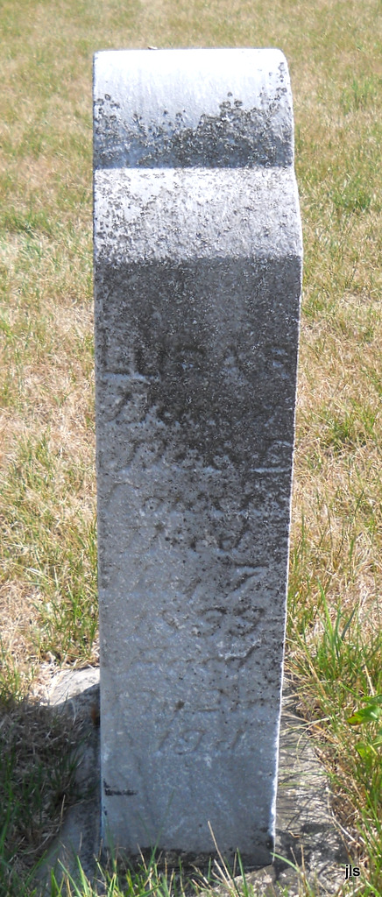
Photo by Jackie Sanders

No obit found at this time

