Ella M. Cossaint
October 10, 1879 – April 6, 1880

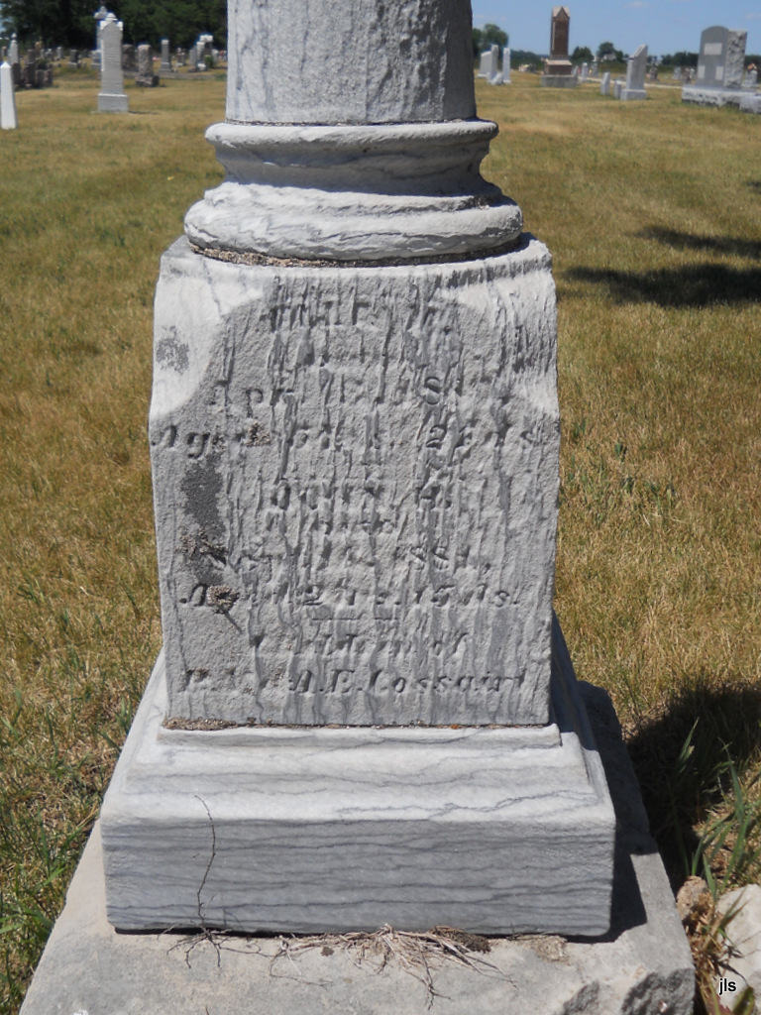
Photo by Jackie Sanders

No obit found at this time

