Harriet (Eckrote) Bucher
May 14, 1842 – September 7, 1922

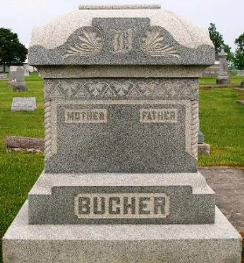
Photo by Jackie Sanders
Hariet Bruder
in the Indiana, Death Certificates, 1899-2011
Name: Hariet Bucher [Hariet Eckrote]
Gender: Female
Race: White
Age: 80 years
Marital status: Widowed
Birth Date: 14 May (no year stated) [abt 1842]
Birth Place: Penn
Death Date: 7 Sep 1922
Death Place: Bluffton, Wells, Indiana, USA
Father: Joseph Eckrote
Mother: Harriet Rinard
Burial: Geneva, Ind.

