Mildred (Gallimore) Bryan
July 7, 1913 – May 10, 1997

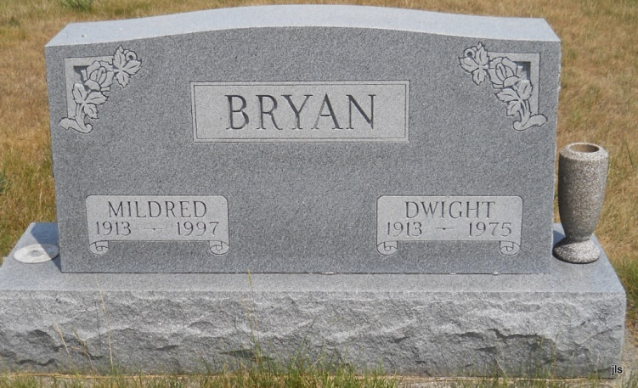
Photo by Jackie Sanders

Mildred Gallimore Bryan, 83, died Saturday at home in Zionsville.
She was a homemaker.
Her husband, Dwight, died in 1975 and a son, Robert, died in 1985.
Surviving are a son, Richard of Zionsville; three sisters, Mabelene Poiry of Fort Wayne, Mary Godby of Muncie and Cleta Cline of Marion; five grandchildren and five great-grandchildren.
Graveside services were Thursday at Alberson Cemetery, east of Petrolum.
Memorials to donor’s choice.
Arrangements by Flanner & Buchanan Mortuary, Zionsville.

Fort Wayne Journal-Gazette (IN); May 16, 1997, page 3C

