Jacob B. Brown
April 10, 1843 – December 25, 1928

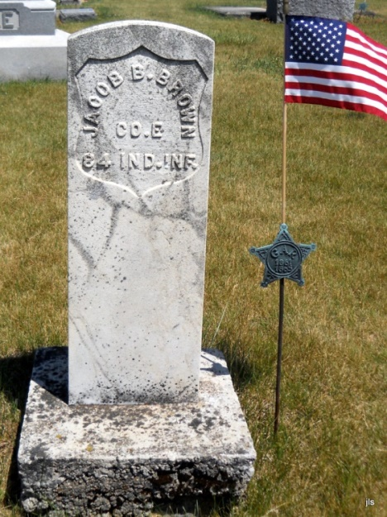
Photo by Barbara Baker Anderson
Jacob B Brown
in the Indiana, Death Certificates, 1899-2011
Name: Jacob B Brown
Gender: Male
Race: White
Age: 85
Marital status: Widowed
Birth Date: 10 Apr 1843
Birth Place: Indiana
Death Date: 25 Dec 1928
Death Place: Nottingham, Wells, Indiana, USA
Father: Phillip Brown
Informant: W. M. Brown
Burial: Dec. 28, 1928; Alberson Cemetery

