Infant son Brown
August 23, 1903 – August 23, 1903

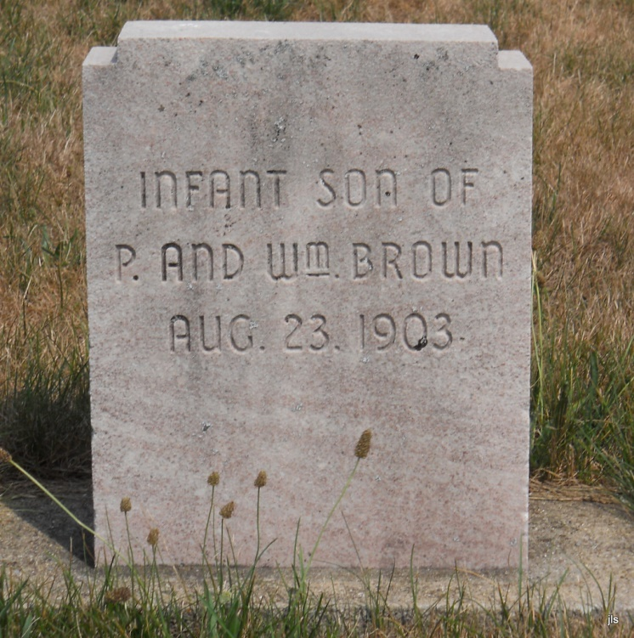

No obit found at this time

