Pearl (Eckrote) Booher
April 9, 1904 – October 10, 1942

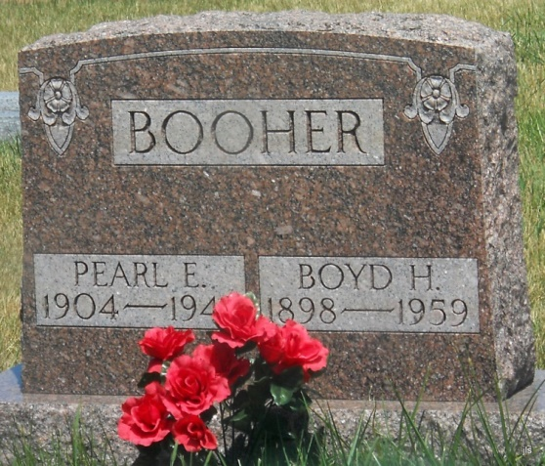
Photo by Jackie Sanders
Pearl Boucher
in the Indiana, Death Certificates, 1899-2011
Name: Pearl Booher
[Pearl Eckrote]
Gender: Female
Race: White
Age: 38
Marital status: Married
Birth Date: 9 Apr 1904
Birth Place: Indiana
Death Date: 10 Oct 1942
Death Place: Decatur, Decatur, Indiana, USA
Father: Harvey Eckrote
Mother: Emma Sales
Spouse: Boyd Booher
Informant: Boyd Booher, Geneva, Ind.
Burial: Oct. 13, 1942; Alberson Cemetery, Geneva, Ind.

