Pansy Mary Jane (Pickering) Bodley
November 20, 1896 – June 22, 1991

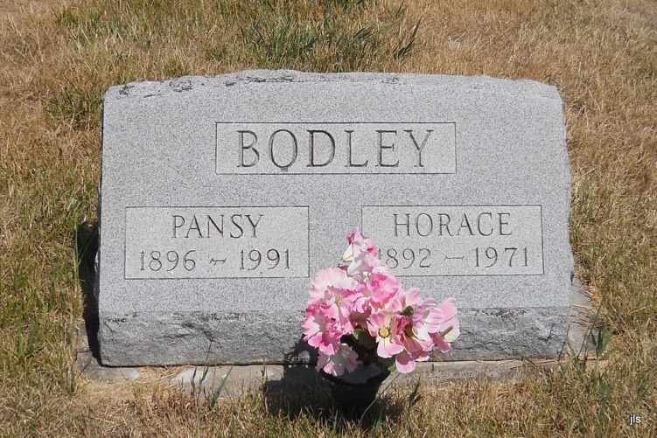
Photo by Jackie Sanders

Pansy Bodley, 94, of Petroleum died Saturday in Bluffton Community Care Center.
She was the widow of Horace, who died in 1971.
Surviving is a niece, Mary Paul of Bloomington, Ill.
Services are 10:30 a.m. tomorrow in Goodwin Memorial Chapel, Bluffton, where calling is 2 to 9 p.m. today, and 9 to 10:30 a.m. tomorrow. Burial will be in Albertson Cemetery.

Fort Wayne News-Sentinel (IN); June 24, 1991

