Mary E. (Kimble) Blocher
1867 - 1888

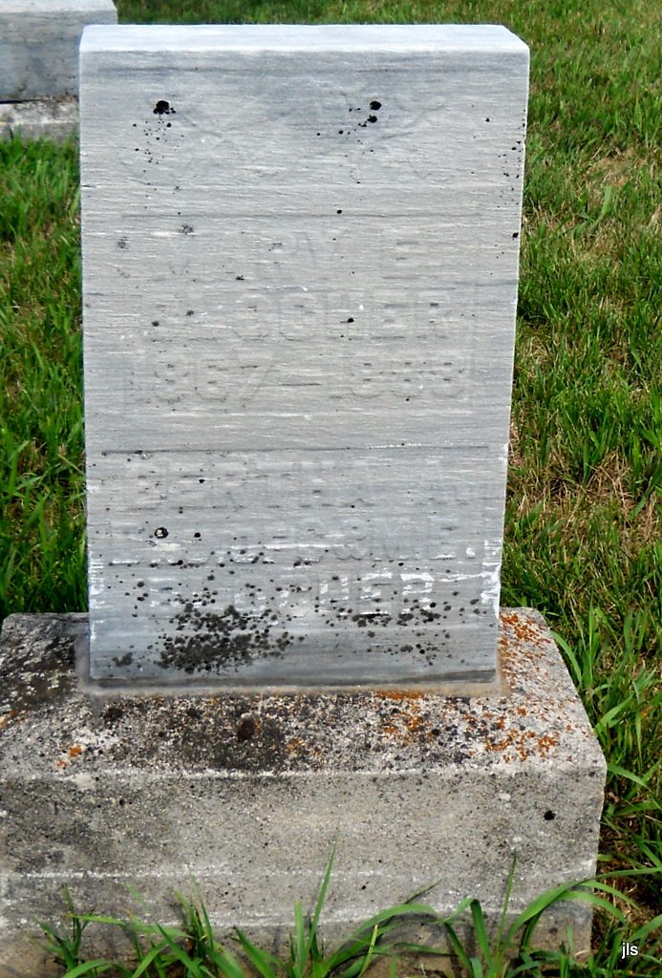
Photo by Jackie Sanders

No obit found at this time

