Lawrence H. Blocher
June 11, 1892 – November 15, 1970

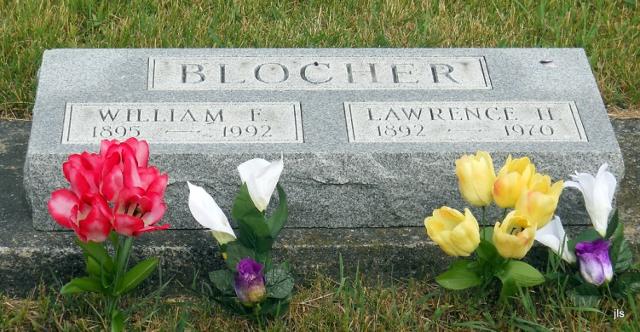
Photo by Jackie Sanders
Lawrence Blocher, 78, of Route 2, Bryant, Indiana and a life resident of Wells County died Monday at Community Hospital. Born in Wells County, June 11, 1893, he was a son of John and Amanda Havens Blocher.
Surviving are a brother and a sister, Fred Blocher and Mrs. Pearl Hesher, both of Bryant, Route 2.
Services will be Wednesday at the Thoma Funeral Home; burial in Alberson Cemetery.

Bluffton News-Banner, Wells County, Indiana
November 9, 1970

*****
Indiana, Death Certificates, 1899-2011
Name: Laurence H Blocher
Gender: Male
Race: White
Age: 76
Marital status: Never Married (Single)
Birth Date: 11 Jun 1892
Birth Place: Indiana
Death Date: 9 Nov 1970
Death Place: Bluffton, Wells, Indiana, USA
Father: Ida Blacher
Mother: Amanda Havens
Informant: Fred Blocher; brother
Burial: Nov. 11, 1970; Alberson Cemetery, Geneva, Ind.

