Opal Leona (Hesher) Ball
July 28, 1906 – August 20, 1986

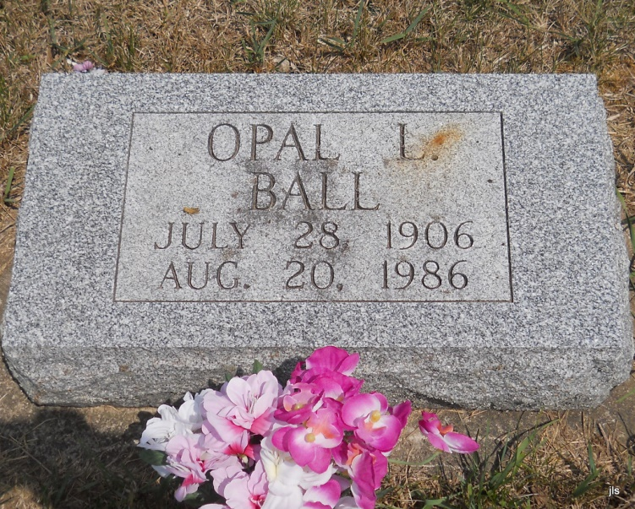
Photo by Jackie Sanders
Bluffton – Opal Leona Ball, 80, died at 8:15 pm Wednesday in Caylor-Nickel Medical Center.
Her husband, Martin, died in 1973.
Surviving are a son, James F. Grice, of Bluffton; a daughter, Patricia Bouse of Bryant; five sisters and seven grandchildren.
Services at 1:30 pm Saturday in Thoma-Rich Funeral Home, with calling after 1 pm today.

Fort Wayne Journal-Gazette (IN); August 22, 1986, Page 2C

