Bertha May (Coffman) Anson
April 18, 1886 – August 28, 1915

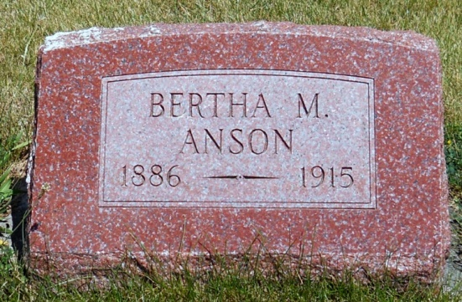
Photo by Jackie Sanders

Died at Petroleum

Bluffton, Indiana – August 31. Ms. Bertha Anson, aged 29, whose home is in Huntington, died at the home of her father, Jacob Kauffman, at Petroleum, after a prolonged illness with tuberculosis.
Mrs. Anson had been in Missouri for her health, but received no benefit and returned to her father’s home in Wells County several weeks ago.
The surviving relatives include her husband and one daughter, Mildred.

News-Sentinel, Fort Wayne, IN; August 31, 1915, Page 3

*****
Indiana, Death Certificates, 1899-2011
Name: Bertha Mae Anson [Bertha Mae Coffman]
Gender: Female; Race: White; Age: 29; Marital Status: Married
Birth Date: 18 Apr 1886; Birth Place: Indiana
Death Date: 28 Aug 1915; Death Place: Petroleum, Wells, Indiana, USA
Father: Jacob Coffman; Mother: Amelia Green
Informant: Fred Anson; husband
Burial: Aug. 30, 1915; Alberson Cem.
Contributed by Karin King

