Rosella (Taylor) Anderson
October 17, 1879 – April 20, 1976

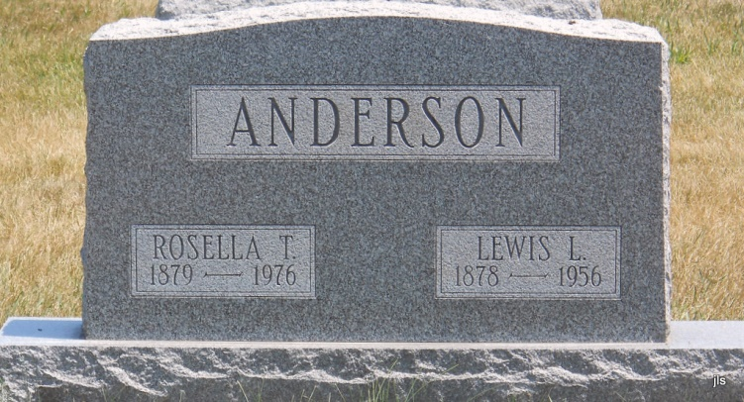
Photo by Jackie Sanders

Rosella Anderson
in the Indiana, Death Certificates, 1899-2011
Name: Rosella Anderson
[Rosella Taylor]
Gender: Female
Race: White
Age: 96
Marital Status: Widowed
Birth Date: 17 Oct 1879
Birth Place: Wells Co Indiana
Death Date: 20 Apr 1976
Death Place: Bluffton, Wells, Indiana, USA
Father: Joseph C Taylor
Mother: Mary Satter
Informant: Mrs. James Powell; guardian; Bluffton, Ind.
Burial: April 22, 1976; Alberson Cemetery, Wells County, Ind.

