Harold Guy Anderson
January 1, 1906 – September 18, 1977

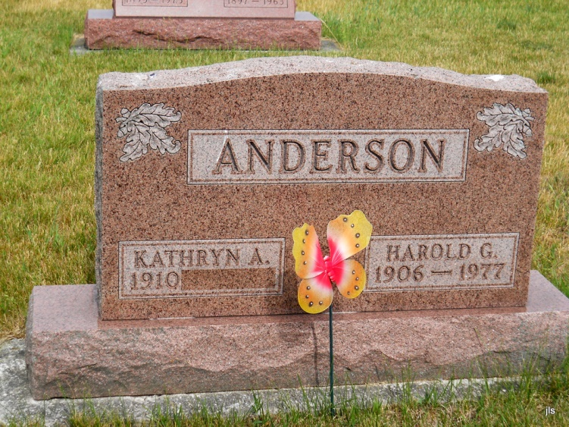
Photo by Jackie Sanders

Harold G. Anderson

Services for Harold G. Anderson, 71, of 2914 New Haven Ave., will be at 1 pm Friday in Downing Funeral Home, Geneva. He died at 5:15 am yesterday in St. Joseph’s Hospital. Mr. Anderson, a native of Geneva, was a retired employee of Indiana Wire Die Co.
Surviving are his wife, Kathryn A.; a son, William P., Indianapolis; a daughter, Mrs. Barbara Ely of Leo; a stepdaughter, Mrs. Shirley Gordon, Santa Monica, Calif.; two sisters, Elizabeth and Helen Anderson, Geneva; and two brothers, Dale, Peoria, Ind., and Clifton, Decatur.
Friends may call at D. O. McComb & Sons Lakeside Funeral Home from 2 to 9 pm today. Burial will be in Alberson Cemetery, Geneva.

For Wayne Journal-Gazette (IN); October 19, 1977, page 2C

