Sarah Olive (Davis) Alberson
February 18, 1858 – May 6, 1939
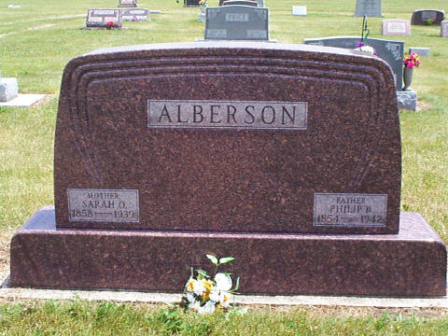
Photo by Jackie Sanders
Sarah Olive Alberson
in the Indiana, Death Certificates, 1899-2011
Name: Sarah Olive Alberson
[Sarah Olive Davis]
Maiden Name: Alberson
Gender: Female
Race: White
Age: 81
Marital Status: Married
Birth Date: 18 Feb 1858
Birth Place: Adams Co. Ind.
Death Date: 6 May 1939
Death Place: Nottingham R.R, Wells, Indiana, USA
Father: T. Davis
Mother: Alice Rogers
Spouse: Billy B. Alberson
Informant: Mrs. Phillis Alberson; Nottingham
Burial: May 10, 1939; Alberson Cemetery

