Raleigh Robert Alberson
May 9, 1918 – April 25, 1966
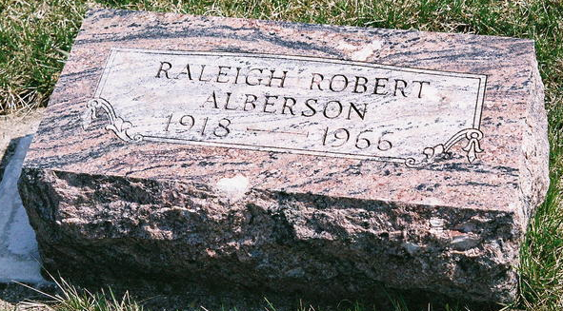
Photo by Jackie Sanders

Raleigh Alberson

Services for Raleigh (Bus) Alberson, 47, R. R. 2, Roanoke, will be at 11 am Thursday in Mungovan & Sons Mortuary, Rev. Robert A. Jaeger officiating. Burial will be in the Alberson Cemetery, Bluffton.
Mr. Alberson died at 8:20 pm Monday in St. Joseph’s Hospital where he had been a patient one week.
He resided here 20 years and was employed as a truck driver with Levin & Sons, Inc.
Surviving are his wife, Ina; two sons, Alva and Gary Bill, both of Bluffton; his stepmother, Mrs. Dora Alberson; three daughters, Marchilla, at home; Mrs. Margaret Goberg, Pittsburgh, Pa., and Mrs. Bonnie Kay Williams, Bluffton; two stepsons, Milton and Michael Bressler, both at home; five stepdaughters, Patricia, Debra and Ruth Bressler, all at home, Miss Helen Bressler, Kenmore, NY and Mrs. Alice Lewis, Cherokee, Ia.; two brothers, Milo, Indianapolis, and Clyde, Keystone; a sister, Mrs. Roy Harris, Keystone; and a grandchild.
Friends may call at the mortuary until time of services.

Journal-Gazette, Fort Wayne, IN; April 27, 1966, Page 4B

