Infant Daughter Alberson

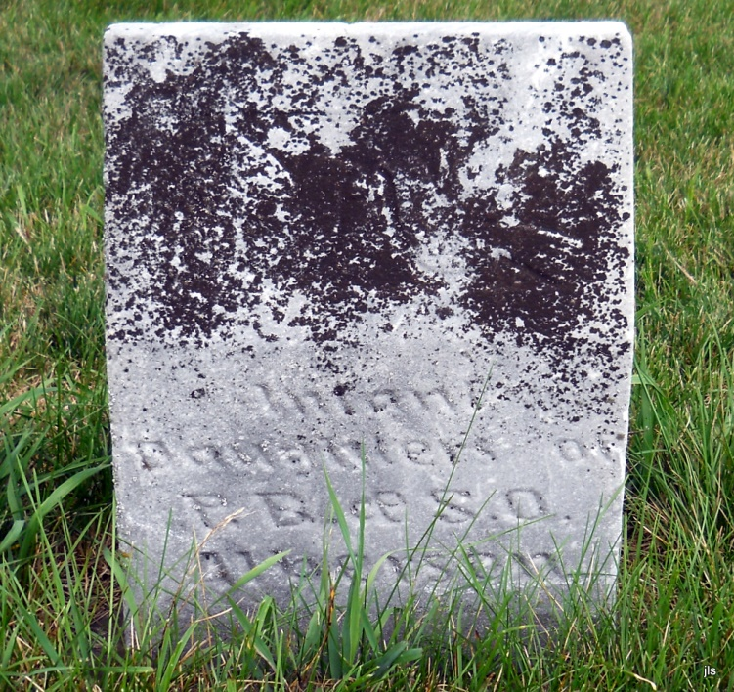
Photo by Jackie Sanders

No obit found at this time

