Herbert LaVaughn Alberson
October 28, 1915 – October 12, 1981

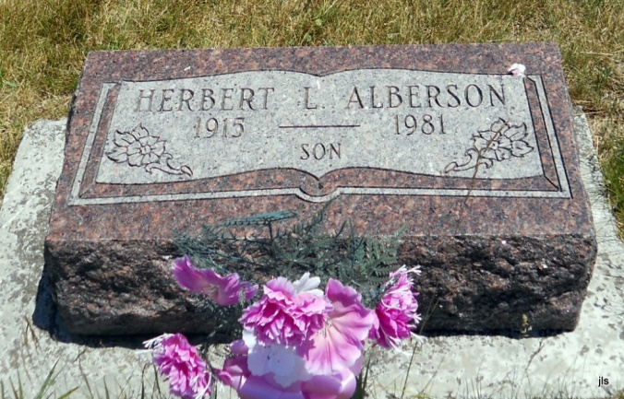
Photo by Jackie Sanders

Herbert L Alberson
in the Indiana, Death Certificates, 1899-2011
Name: Herbert L Alberson
Gender: Male
Race: White
Age: 65
Marital Status: Never Married (Single)
Birth Date: 23 Oct 1915
Birth Place: Indiana
Death Date: 12 Oct 1981
Death Place: Domestic, Wells, Indiana, USA
Father: J. Earl Alberson
Mother: Deuaner Evans
Informant: Ed Alberson; brother; Bryant, Ind.
Burial: Oct. 16, 1981; Alberson Cemetery, Domestic, Ind.

