Henry Alberson
June 21, 1852 – May 12, 1903

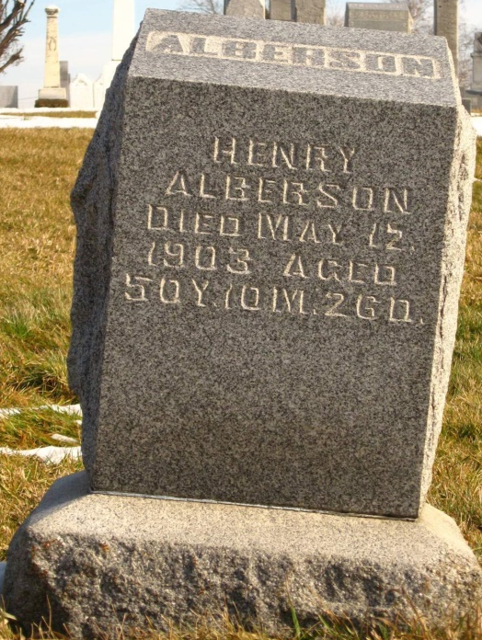
Photo by Tombstoner & Family

Henry Alberson Dead

Henry Alberson, aged 51, died Sunday evening at the home of his sister, Mrs. Winfield Settles, near Phoenix. He was a sufferer with tuberculosis. The deceased was unmarried. The funeral was held Monday from the Settles residence with interment in the Alberson cemetery.
Mr. Alberson had been in poor health for some time and the worry caused him to become mentally weak a few weeks ago. He was brought to town and put in jail until he could be sent to Richmond for treatment but when he began rapidly to fail in health he was taken back to the home of his sister.

Bluffton Chronicle, Wells County, IN; May 20, 1903, p. 4, c. 3

