Donald K. Addington
September 9, 1938 – May 16, 2013

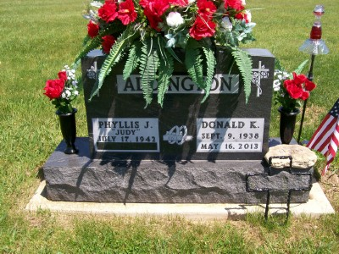
Photo by Scott Shoup

Donald K. Addington, age 74 passed away Thursday afternoon at his residence following an extended illness with cancer.
Survivors include wife Phyllis, son Denny Addington, daughter Amy Addington, brother, George Addington, Jr., sister, Vesta L. Hartnegel and the following grandchildren: Ashley Ann Addington, Carson Donald Addington and Ace Levi Addington.

Journal-Gazette, Fort Wayne, IN; May 18, 2013

