Isabel E. Zehr
May 3, 1901 – June 26, 1969

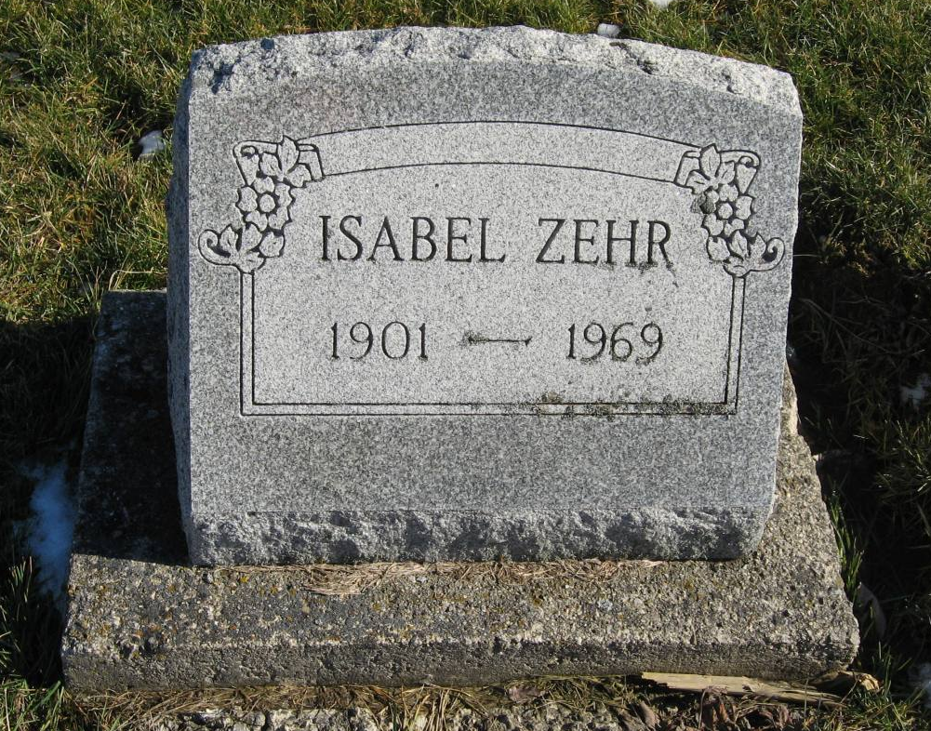
Photo by Tombstoner & Family

Indiana, Death Certificates, 1899-2011

Name: Isabel E Zehr
Gender: Female
Race: White
Age: 68
Marital status: Never Married (Single)
Birth Date: 3 May 1901
Birth Place: Indiana
Death Date: 26 Jun 1969
Death Place: Fort Wayne, Allen, Indiana, USA
Father: Christian Zehr
Mother: Emma Amstutz
Informant: Paul Zehr, nephew
Burial: June 28, 1969; Mt. Hope Cemetery

