George Zehr
November 11, 1842 – January 28, 1934

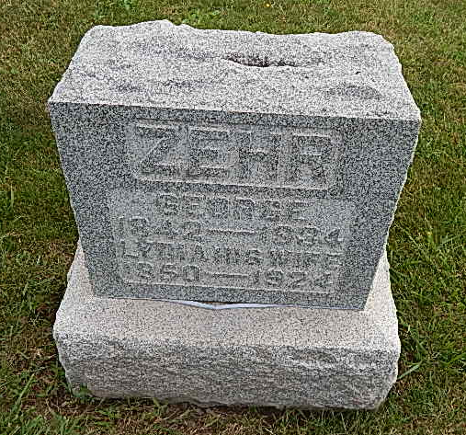
Photo by Alicia Kneuss

Indiana, Death Certificates, 1899-2011

Name: George Zehr
Gender: Male; Race: White; Age: 91y, 2m, 17d
Marital status: Widowed
Birth Date: 11 Nov 1842; Birth Place: Germany
Death Date: 28 Jan 1934; Death Place: Hartford, Adams, Indiana, USA
Father: George Zehr; Mother: unknown ; Spouse: Lydia Roth
Informant: Chris Zehr
Burial: 1/31/1934, Defenseless Mennonite Cem.

*****
GEORGE ZEHR.
George Zehr, an enterprising and successful farmer of Wabash township, Adams county, Indiana, is a native of Germany, where he was born on November 11, 1842, and is a son of Jacob and _____ (Steinman) Zehr. These parents were agriculturists and never left the fatherland.
George Zehr obtained a good education in the public schools of his native land and in 1866, in order to better his financial interests, emigrated to America and located in Wayne county, Ohio , where he lived for two years, and then removed to Adams county, where he spent a year working at the carpenter trade. Subsequently he located in McLain county, Illinois , and also spent three years in Taswell and Livingston counties, Illinois . In 1872 he returned to Adams county and bought a farm of ninety-two acres, located "in section 19, Wabash township, which at that time was densely covered with timber excepting a tract of about ten acres. For a number of years their home was in a log cabin, but in 1887 this was replaced by a splendid two-story frame residence, followed two years later by the erection of a large barn, a large part of the carpenter work on both buildings having been done by Mr. Zehr. Today he owns as good a farm as can be found in Adams county, having put upon it many substantia! and permanent improvements. In addition to agriculture he gives considerable attention to the raising of live stock, in which he has been successful.
In 1872 Mr. Zehr married Miss Lydia Roth, daughter of Christian and Mary (Hirschy) Roth, the father a native of France and the mother of Switzerland . They came to America separately many years ago and settled in Adams county, Indiana, where they subsequently resided until death. Mrs. Zehr was born in French township, Adams county, and was here reared and received her education. Unto Mr. and Mrs. Zehr have been born ten children, namely : Christian, David, Jacob, Mary and Sarah (twins), Rosa, Enos, Simeon, William and Lillie, now deceased. The family are members of the Mennonite church and take an active interest in everything that tends to the upbuilding of the community.
Snow's History of Adams County, Indiana, John Fletcher Snow, B. F. Bowen, Indianapolis, IN, 1907,(image 549)

