Christian V. Zehr
June 1, 1873 – November 7, 1965

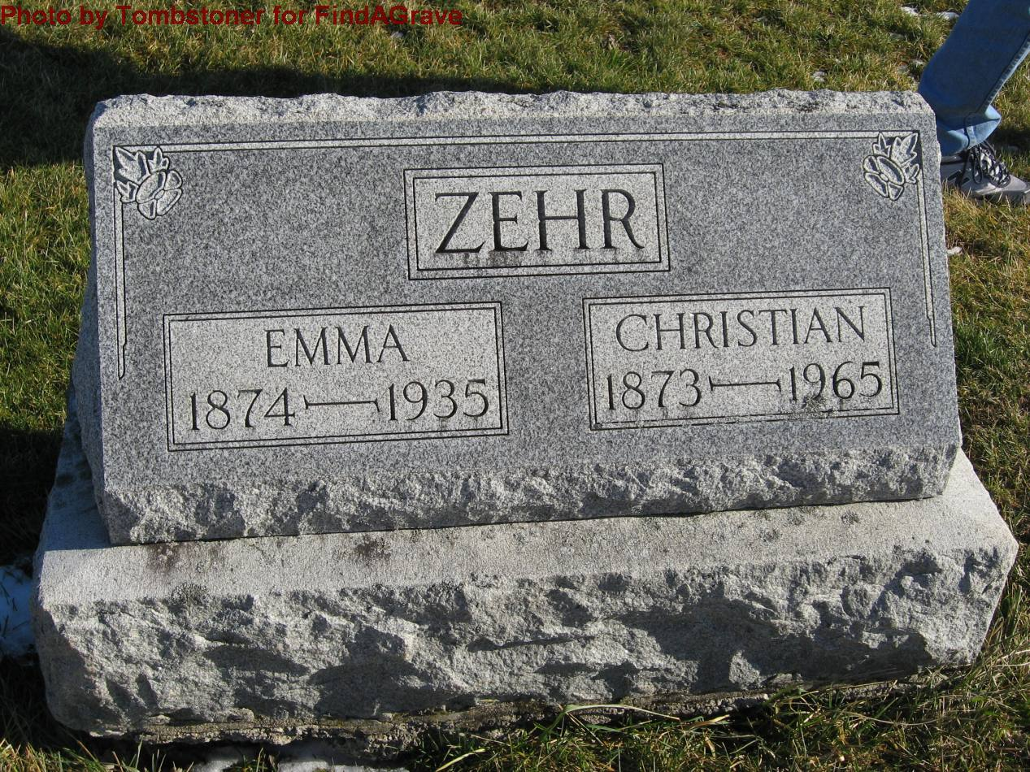
Photo by Tombstoner & Family

Indiana, Death Certificates, 1899-2011

Name: Christian Zehr
Gender: Male
Race: White
Age: 92
Marital status: Widowed
Birth Date: 1 Jun 1873
Birth Place: Indiana
Death Date: 7 Nov 1965
Death Place: Bluffton, Wayne, Indiana, USA
Father: George Zehr
Mother: Lydia Roth
Informant: Albert Zehr, son
Burial: 11/9/1965, Evan. Mennonite Cem.

